This workflow is based on the same process shown in your videos:
- define brand → generate visuals → animate → build site → deploy → SEO

PHASE 1 — ENVIRONMENT SETUP (DO THIS FIRST ONLY)
Goal
You will have a working AI website-building environment ready before touching design or code.

STEP 1 — Install Core Tools (Do NOT skip anything)
1. Install AntiGravity (IDE)
- Download from: https://antigravity.google/
- Install like VS Code
- Open it once installed
Verify:
- You see file explorer (left)
- Editor (center)
- AI chat panel (right)
AntiGravity acts like a VS Code-style IDE with built-in AI agent workflow.

2. Install Claude Code (inside AntiGravity)
Inside AntiGravity:
- Go to Extensions
- Search: Claude Code
- Install
- Log into your Claude account
Verify:
- You can open a Claude terminal or chat panel
- You can type a prompt and get a response

3. Create Your Project Folder
Create this EXACT structure:
AI-Website-Project/
Then open it in AntiGravity:
- File → Open Folder → select it
- Click Trust Workspace

4. Create Starter Structure
Inside your project folder, create:
AI-Website-Project/
├── assets/
│ ├── images/
│ ├── video/
│ └── logos/
├── copy/
├── install/
├── prompts/
├── site/
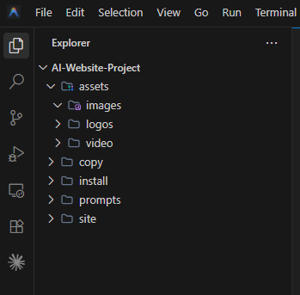

5. Test Claude Can Work in Your Project
In Claude panel, run this:
Create a simple HTML file called index.html with a headline that says "Test Successful".
Verify:
- File appears in your folder
- You can open it in browser
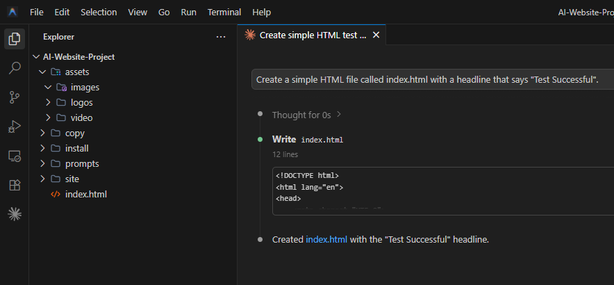

PHASE 2 — DEFINE YOUR WEBSITE (FOUNDATION)
Goal
Create a clear, structured blueprint for your AI Consultant website so Claude builds it correctly on the first pass.

STEP 2 — Define Your Business + Website Structure
Use this EXACT input (pre-filled for you based on your use case).
Paste this into a new file:
Create file:
copy/website-plan.txt
Paste this:
Business Name: [Your Business Name]

Type: AI Consulting Agency

Target Audience:
Small to medium-sized businesses that want to automate operations, improve efficiency, and leverage AI without technical complexity.

Core Services:
- Custom AI solutions
- Business process automation
- AI chatbots / assistants
- Workflow integrations
- AI strategy consulting

Primary Goal:
Get users to book a consultation call.

Primary CTA:
"Book a Free AI Consultation"

Secondary CTA:
"See How It Works"

Brand Personality:
- Fun but professional
- Confident
- Modern
- Slightly playful but still premium

Design Style:
- Clean, minimal
- Dark + light contrast sections
- Subtle animations
- Premium SaaS look (NOT generic AI look)

Color Direction:
- Primary: Deep blue / black
- Accent: Neon blue or purple
- Background: White + dark sections

Pages Needed:
- Home
- About
- Services
- Testimonials
- Contact

Homepage Sections (IMPORTANT):
1. Hero (with animation)
2. Problem (why businesses struggle)
3. Solution (what you do)
4. Services overview
5. How it works (3 steps)
6. Testimonials / proof
7. Final CTA
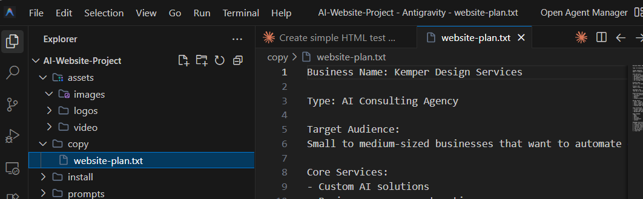

STEP 2 CHECKPOINT
Confirm:
- File created
- Content pasted exactly

STEP 3 — Generate Your FIRST REAL WEBSITE PROMPT
Now we create the prompt that builds your site.

Create file:
prompts/homepage-build.txt
Paste this:
Build a premium, modern AI consulting website homepage.

Business context:
- AI consulting agency for small businesses
- Focus on automation, AI tools, and efficiency

Design requirements:
- Clean, high-end SaaS style
- NOT generic AI-looking
- Balanced whitespace
- Smooth section transitions
- Subtle animations

Hero section:
- Large bold headline
- Subheadline explaining value
- Primary CTA: "Book a Free AI Consultation"
- Secondary CTA: "See How It Works"
- Placeholder for animated visual (we will add later)

Sections to include:
1. Problem section (pain points)
2. Solution section (your approach)
3. Services (cards layout)
4. How it works (3-step process)
5. Testimonials (3 examples)
6. Final CTA section

Technical requirements:
- Responsive (mobile-first)
- Clean HTML/CSS structure
- Semantic layout
- Easy to expand later
- Modern font styling

Tone:
- Friendly but authoritative
- Clear, not technical jargon

Return:
- Full working HTML file
- Embedded CSS (no external dependencies)
- Clean, readable code
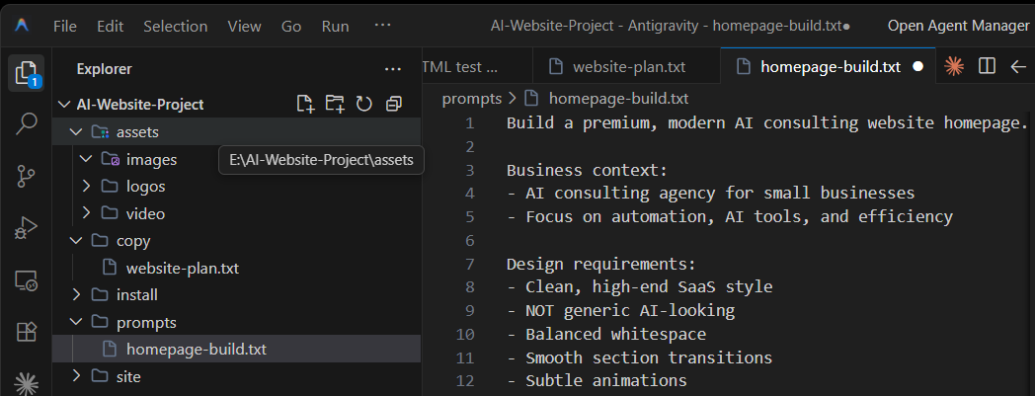

STEP 3 — Run It
In Claude panel, paste:
Read prompts/homepage-build.txt and generate the homepage.
Save it as site/index.html
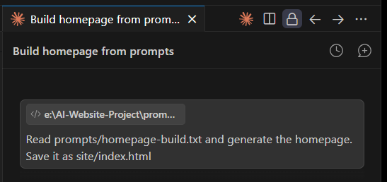

STEP 3 CHECKPOINT
Verify:
- site/index.html created
- Opens in browser
- Looks like a real landing page (not plain text)
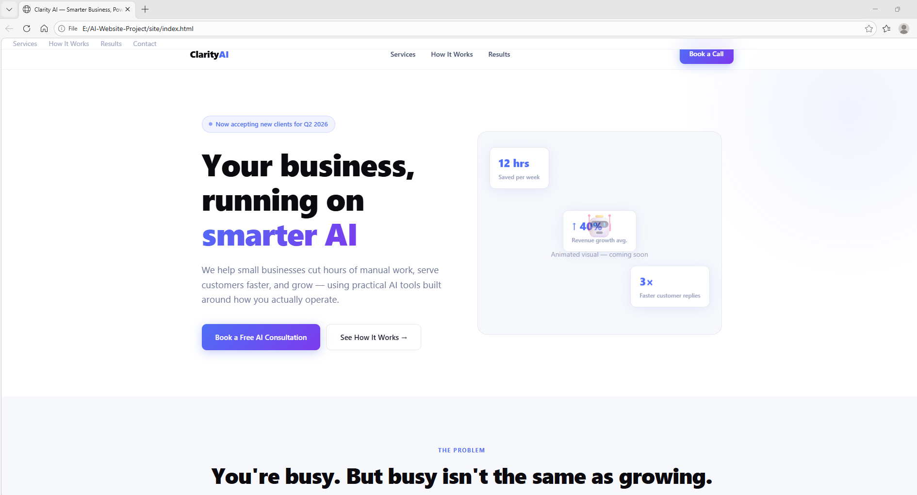

STEP 4 — Upgrade the Design (IMPORTANT)
Now improve it (this is where quality jumps).
Paste into Claude:
Improve the current homepage design:

- Make spacing more premium
- Improve typography hierarchy
- Add subtle hover effects
- Improve button styling
- Add section separators
- Make it feel like a high-end SaaS website

Do NOT change structure.
Only improve visual quality.

STEP 4 CHECKPOINT
Verify:
- Buttons look better
- Sections feel spaced out
- Overall looks more “expensive”

PHASE 3 — CREATE THE HERO VISUALS
Goal
Create the two key hero images you need for the animated website intro:
- start frame
- end frame
These will later become the motion hero section.

STEP 5 — Decide the Hero Concept
For your AI consulting website, use this concept:
Hero idea
A premium digital control center representing business automation.
Visual direction
- floating dashboard panels
- subtle holographic UI elements
- glowing workflow lines
- premium abstract 3D composition
- clean composition with empty space for headline and buttons
This fits the style shown in the resources: polished, animated, premium, and clearly commercial instead of generic AI art.

STEP 5A — Create Your Visual Prompt File
Create this file:
prompts/hero-start-image.txt
Paste this:
Create a premium website hero image for an AI consulting agency.

Scene:
A sleek futuristic business automation command center with floating interface panels, glowing workflow connections, abstract 3D dashboard elements, subtle holographic displays, and a polished premium technology atmosphere.

Style:
- premium SaaS website hero
- modern, elegant, high-end
- clean composition
- subtle cinematic lighting
- realistic 3D mixed with polished UI
- not busy or cluttered
- designed for commercial website use

Composition requirements:
- 16:9
- leave clean negative space on the left or center-left for headline and buttons
- no important objects touching the edges
- balanced layout
- white or very light background OR dark premium background with strong contrast
- visually impressive but not chaotic

Brand feel:
- fun but professional
- modern
- premium
- confident

Colors:
- deep blue
- black
- subtle purple or neon blue accents

Output:
A highly polished hero image suitable for the homepage of a premium AI consulting website.

STEP 5B — Generate the Start Image
Use your preferred image generator.
If you are following the workflow from the videos, use Nano Banana 2.
Generate at least 4 versions.
What you are looking for
Pick the best image using this checklist:
- looks premium
- not overcrowded
- clear space for text
- good lighting
- fits 16:9
- looks like a real website hero
- does not feel like random AI wallpaper
Save the winner as:
assets/images/hero-start.png

STEP 6 — Create the End Frame Prompt
Now create the second image.
This should feel like a transformed, expanded, or “activated” version of the first.
Create this file:
prompts/hero-end-image.txt
Paste this:
Using the start image as reference, create a second premium website hero image for an AI consulting agency.

Goal:
This should be the transformed end-state of the original scene, as if the automation platform has fully activated.

Requirements:
- maintain the same camera angle
- maintain the same overall composition
- preserve lighting consistency
- preserve style consistency
- keep the same premium commercial look

Scene changes:
- dashboard elements are more expanded
- floating panels are more separated
- glowing workflow lines are more active
- subtle motion-ready transformation
- the scene feels more alive, dynamic, and activated

Composition rules:
- 16:9
- keep clean negative space for website text
- no edge collisions
- polished and elegant
- no clutter
- website-ready

Colors:
- deep blue
- black
- subtle purple or neon blue accents

Output:
A visually consistent end-frame image designed for smooth animation from the start image.

STEP 6B — Generate the End Image
When generating this second image:
- use your chosen start image as the reference
- keep the same composition
- generate multiple versions
- choose the one that matches best
Save the winner as:
assets/images/hero-end.png

STEP 7 — Organize the Files
By the end of this step, your folder should contain:
assets/
images/
hero-start.png
hero-end.png

✅ VISUAL QUALITY CHECKPOINT
Before moving on, verify these:
Start image
- premium
- clean
- text space available
- strong hero composition
End image
- clearly related to start image
- same camera angle
- same general layout
- looks like a transformation, not a different scene

TROUBLESHOOTING
If the image looks too “AI generated”
Revise the prompt by adding:
commercial website hero image, polished, art-directed, realistic materials, premium UI composition, not fantasy art, not concept art poster, not game splash screen
If the image is too busy
Add:
minimal composition, fewer objects, more whitespace, stronger focal point
If there is no room for text
Add:
large empty area on left side for website headline and CTA buttons
If the second image does not match the first
Add:
strictly preserve composition, angle, perspective, lighting, and subject arrangement from the referenced image

⛔ STOP HERE
Do not create the animation yet.

WHAT YOU SHOULD HAVE NOW
You should now have:
- hero concept ✅
- start frame ✅
- end frame ✅

NEXT STEP
Next we will do:
PHASE 4 — TURN THE TWO IMAGES INTO ANIMATED HERO VIDEO
We will create the transition prompt, generate the animation, save it properly, and then insert it into the homepage.
Reply with:
“images done”
and include whether your images came out:
- good
- decent but need help
- bad and need better prompts

